**A Comparative Financial analysis of CIPLA Ltd. and LUPIN Ltd.**

Bhuvanavarsh Shivaprasad Hiremath

Date: 16-07-24

**Table of Contents**

1. Introduction
2. Overview of Cipla and Lupin
3. Project Objectives
4. WACC Calculations
   1. Cipla ltd.
   2. Lupin ltd.
5. Comparative Analysis
   1. Comparison of WACC values
   2. Interpretations
   3. Impact on Financial Performance and Strategic decisions
6. Conclusion
7. Recommendations
8. Appendices
   1. Appendix A - Monthly Stock prices data
   2. Appendix B - WACC calculation of Lupin ltd
   3. Appendix C - WACC calculation of Cipla ltd
   4. Appendix D - Financial data used from Lupin ltd
   5. Appendix E - Financial data used from Cipla ltd

**1.Introduction**

Cipla and Lupin are two of the leading pharmaceutical companies in India, with a strong presence in both the domestic and global markets. This report aims to provide a comprehensive comparative analysis of the financial performance of these two industry giants, with a focus on their Weighted Average Cost of Capital (WACC).

**2.Overview of Cipla and Lupin**

Cipla is a multinational pharmaceutical company headquartered in Mumbai, India. It is one of the largest pharmaceutical companies in India and a major player in the global generics market. Cipla has a diverse product portfolio spanning various therapeutic areas, including respiratory, anti-HIV, and oncology drugs.

Lupin is another prominent Indian pharmaceutical company, headquartered in Mumbai. It is a leading producer of generic and specialty pharmaceuticals, with a strong presence in the United States, Japan, and other major markets. Lupin's product range includes medications for cardiovascular, diabetic, and infectious diseases, among others.

**3.Project Objectives**

1. Calculate and compare the WACC of Cipla and Lupin.

2. Analyze the implications of the WACC differences on the financial performance and strategic decisions of the two companies.

3. Provide recommendations for Cipla and Lupin based on the findings of the comparative analysis.

**4.WACC Calculations**

To calculate the WACC for Cipla and Lupin, we will use the following formula:

WACC = ${( W}_{e}*R_{e} )+( W_{d}*R_{d}*(1-T))$

Where:

- = Proportion of equity financing

- = Cost of equity

- = Proportion of debt financing

- = Cost of debt

- T = Corporate tax rate

#Cipla WACC Calculation

Based on the financial data from Cipla's latest annual report , the WACC calculation for Cipla is as follows:

- = 0.998294113

- = 11.42504426

- = 0.001705887

- = 52.45666124

- T = 0.298

Plugging these values into the WACC formula we get:

CIPLA-WACC = 11.46837298

#Lupin WACC Calculation

Using the financial data from Lupin's latest annual report , the WACC calculation for Lupin is as follows:

- = 0.974505104

- = 14.43682886

- = 0.025494896

- = 128.2374942

- T = 0.3749

Plugging these values into the WACC formula:

LUPIN-WACC = 14.60832772

**5.Comparative Analysis**

1. Comparison of WACC Values

The WACC for a company represents the average rate of return it must earn on its investments to satisfy its shareholders and debt holders.

The WACC calculations show that Lupin has a higher WACC of 14.6% compared to Cipla's 11.4%. This means that Lupin depends more on equity than Cipla to finance its operations. This indicates that Lupin has a higher cost of capital, which can be attributed to its higher cost of equity.

2. Interpretations

The difference in WACC between Cipla and Lupin suggests that Cipla has a lower cost of capital, which can be advantageous in the following ways:

1. Financing Decisions: Cipla may have an easier time securing financing for new projects or expansions, as its lower WACC makes it a more attractive investment opportunity for lenders and investors.

2. Profitability and Shareholder Value: Cipla's lower WACC implies that the company can generate higher returns on its investments, leading to improved profitability and increased shareholder value.

3. Strategic Flexibility: Cipla's lower cost of capital provides it with more strategic flexibility, allowing the company to pursue riskier but potentially more profitable projects or acquisitions without significantly increasing its overall cost of capital.

On the other hand, Lupin's higher WACC may indicate that the company faces higher financing costs and may need to be more selective in its investment decisions to ensure that projects generate returns that exceed the company's cost of capital.

3.Impact on Financial Performance and Strategic Decisions

1. Capital Budgeting: Cipla's lower WACC means that it can justify investing in projects with lower expected returns, as the cost of capital is lower. Lupin, on the other hand, may need to be more selective and only pursue projects with higher expected returns to overcome its higher cost of capital.

2. Mergers and Acquisitions: Cipla's lower WACC may make it a more attractive acquirer, as it can offer a lower cost of capital to potential targets. Lupin, with its higher WACC, may need to be more cautious in its M&A activities to ensure that any acquisitions are accretive to its overall cost of capital.

3. Dividend Policy: Cipla's lower WACC may allow it to maintain a more generous dividend policy, as the cost of retaining earnings is lower. Lupin, with its higher WACC, may need to strike a balance between reinvesting in the business and distributing dividends to shareholders.

**6.Conclusion**

In conclusion, the comparative analysis of the WACC for Cipla and Lupin reveals that Cipla has a lower cost of capital, which can provide it with a strategic advantage in terms of financing decisions, profitability, and overall financial performance. Lupin's higher WACC, on the other hand, may require the company to be more selective in its investment decisions and to carefully manage its capital structure to ensure that it can generate returns that exceed its cost of capital.

**7.Recommendations**

1. Cipla: Cipla should leverage its lower cost of capital to pursue growth opportunities, both organically and through strategic acquisitions, that can further enhance its market position and profitability.

2. Lupin: Lupin should focus on improving its capital structure and reducing its cost of debt to bring down its overall WACC. This may involve refinancing existing debt, increasing the proportion of equity financing, or exploring alternative financing options.

**Appendix A**

Monthly Stock prices data of Cipla ltd.(BSE), Lupin ltd.(BSE) and BSE Sensex from August 2019 to July 2024

**Appendix B**

WACC calculation of LUPIN ltd

**Appendix C**

WACC calculation of CIPLA ltd.

**Appendix D**

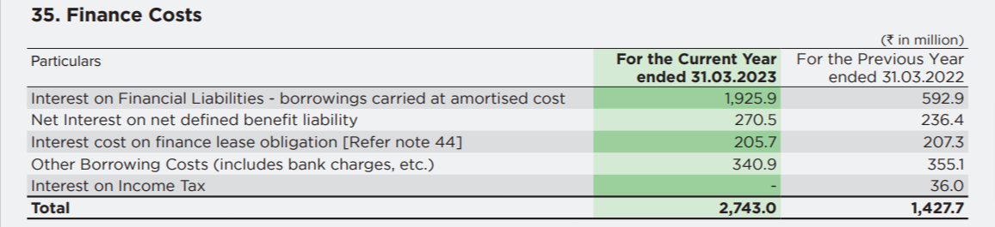Financial data used from Lupin ltd. Consolidated Annual Report and Tax transparency report. (The numbers were in millions. They were converted to crores)



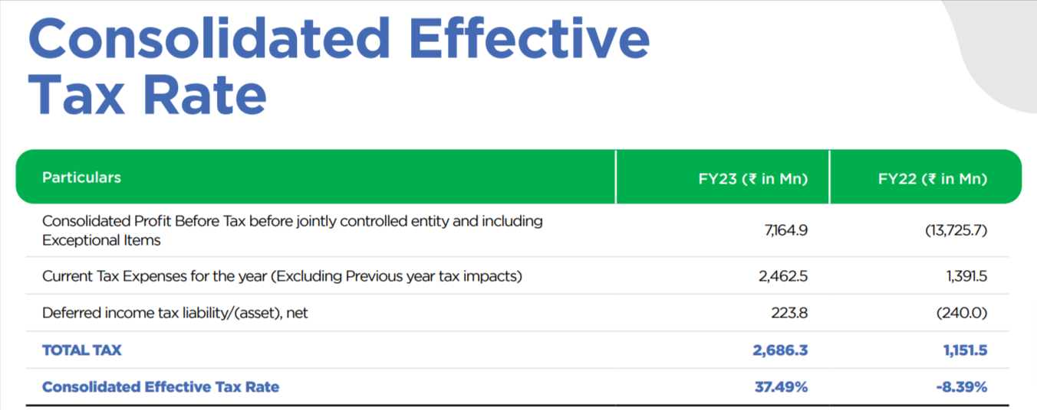

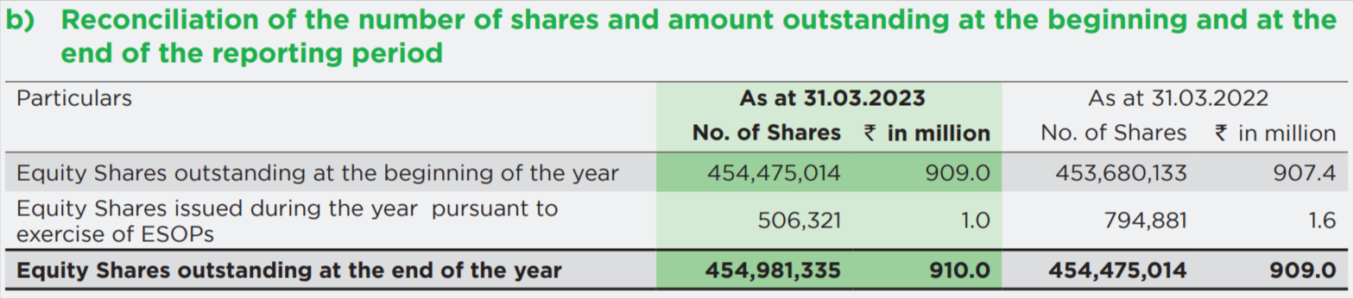

**Appendix E**

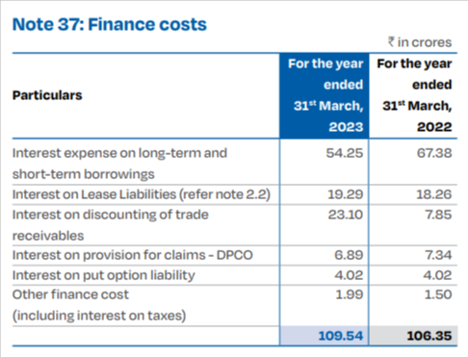Financial data used from Cipla ltd. Consolidated Annual Report.



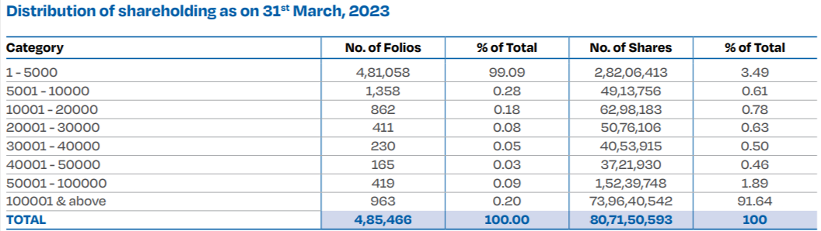

**References**

* Yahoo! (2024, July 17). *Cipla Limited (CIPLA.BO) stock historical prices & data – yahoo finance*. Yahoo! Finance. https://nz.finance.yahoo.com/quote/CIPLA.BO/history/
* Yahoo! (2024, July 17). *Cipla Limited (LUPIN.BO) stock historical prices & data – yahoo finance*. Yahoo! Finance. https://nz.finance.yahoo.com/quote/LUPIN.BO/history/
* Cipla ltd. (2023, March 31). Annual Report FY 2022-23. *Investors/Annual Reports* [ONLINE] [2024, July 17] <https://www.cipla.com/sites/default/files/Annual-Report-FY-2022-23.pdf>
* Lupin ltd. (2023, March 31). Consolidated Financial Statements. *Reports and Financials/Consolidated Financial statements* [ONLINE] [2024, July 17]<https://www.lupin.com/esg-report/img/reports/consolidated-financial-statements.pdf>